***Assignement 1.2:***

Common Linux Command

**1.pwd (Print working directory)**

It will give or show the full path of current working directory

E.g:-Now currently machine is running in home of acadgild directory

/home/acadgild.

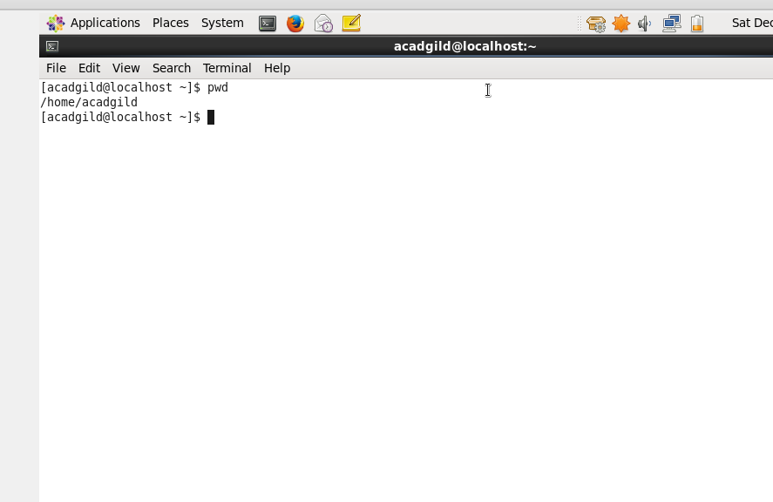

2**. vi –( Visual text editor )**

It will creates a new file, if it is already not exist, otherwise it will opens an existing file.

vi filename

It will operates in Two mode

1.Command mode:- In this mode it will enables to perform administrative tasks such as saving the files, executing the commands, moving the cursor, cutting and pasting the lines or words, as well as finding and replacing. Ti will take everything you type as command

2.Insert Mode :- In this mode it will enables you to insert text into the file. Everything that typed in this mode is taken as input and placed in the file.

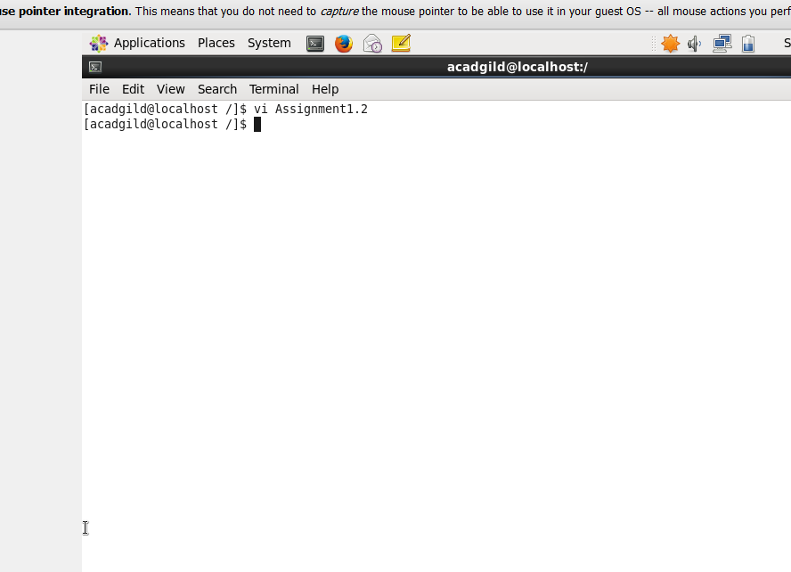

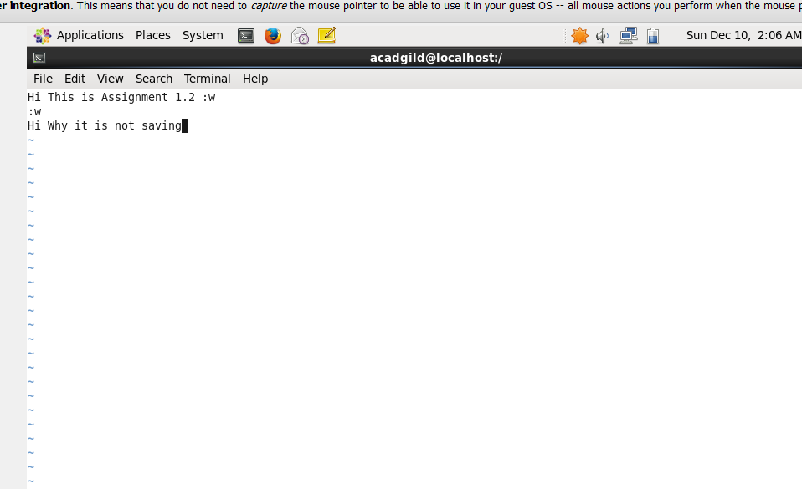

**3. touch:-**

The *touch* [command](http://www.linfo.org/command.html) to create new and empty [files](http://www.linfo.org/file.html). It is also used to change the *timestamps* (i.e., dates and times of the file ) on existing files and [directories](http://www.linfo.org/directory.html).

And we create many empty file at a time

E.g:

touch file1.txt file2.txt:

We can avoid creating new file ,it will just update the accessing time of existing file use –c in command

E.g:-touch –c filename.txt

Use to change access and modification time together using

E,g touch –am filename.txt

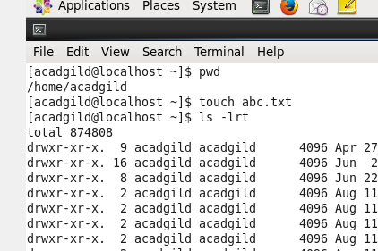

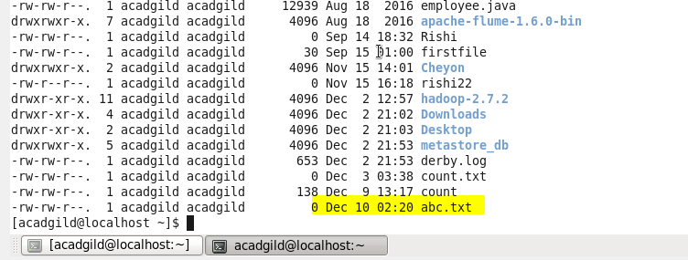

**4. mkdir:-**

The simplest way to create new directory under the folder

*mkdir <foldername>*

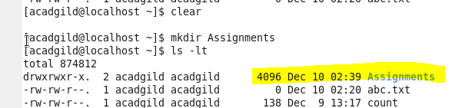

**5. rm:-**

The **rm** command is used for deleting a file. The command **rm** is derived from remove

E.g:-

**rm filename.txt**

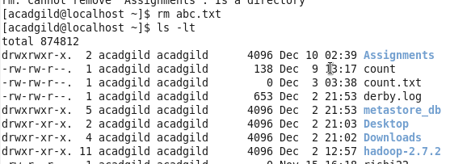

**6. ls**

 ls command is used for list information about files in the current working directory by default. ls command is one of the default shell command in Linux

E.g -- ls

**ls <option>**

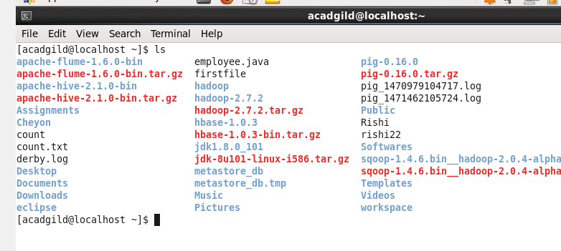

**7.** **echo**

It is used to print the line of text in the file

E.g

Echo Hi Assignment1.2

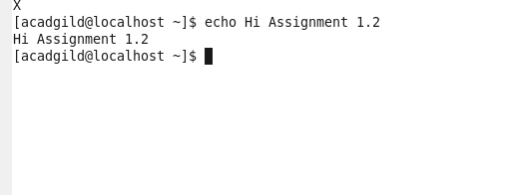

**8. cat**----Concatenate files and gives standard Output

Cat stands for Catenate .It reads data from files and outputs their contents in the file .It is the simplest way to display the contents of a file at the command file .

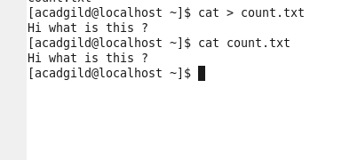

**9. who**

Prints the  print effective userid

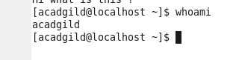

**10.cd**

It is used to the change directory from current directory

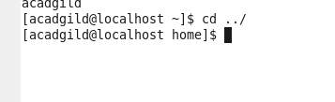

**11.date**

The **date** command is used to print out, or change the value of, the system's time and date information

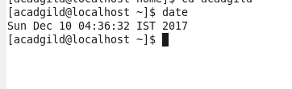

**12.cal:-**

**cal** displays the current month in the [terminal](https://www.computerhope.com/jargon/t/terminal.htm)–(date)

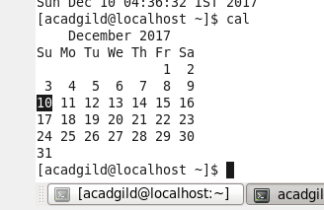

**13.mv**

The **mv** command moves or [renames](https://www.computerhope.com/jargon/r/rename.htm) the files and directories on the [filesystem](https://www.computerhope.com/jargon/f/filesyst.htm).

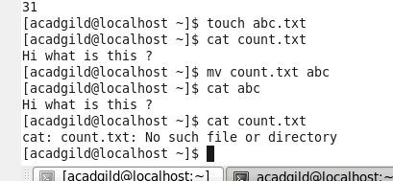

**14.cp:-**

**cp** command is used to make copies of files and directories from other directories .

E.g:-cp orginalfile newfile

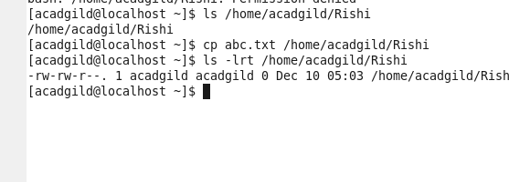

**15.which :-**

It is used to find the executable filr associated with a command name of date

E,g:-which data.

